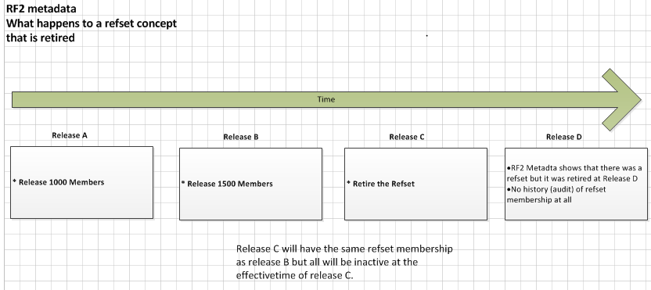
Description

- When moving through Release cycle A and B members are added to a Refset.
- At Release C the Refset is retired and all members are set to inactive with an updated effectivetime
- At Release D all refset membership from all previous releases has been deleted from all file types. The metadata in Release D does indicate a Refset existed and was then retired.

Observations

- If you take a full release at point “A” “B” or “C” (and then following deltas) you will retain full, partial or the last releases refset membership.
- If you take a full release at point D you will not have any refset membership data at all.
- This process also breaks a common release type constraint, for e.g. Release D Full = (Release C Full + Release D Delta).
- Should the refset membership history be removed when moving from Release C to Release D?

Conclusion

- For a specific use case at an international level, this was the process for the non-human Refset that was converted to an extension and required concepts to be retired.
- We have seen this at a UK Extension level, using the RF1 – RF2 Migration Utility written by TermMed.
- The question is around whether this is expected/correct behaviour and is there is guidance documentation on this
- How do other members manage this situation?

