Nutrition Care Process Clinical Project Group
September 2020

Issue: Pilot concept modeling in SNOMED CT

Summary:

- Continued review of SNOMED modeling of pilot terms.
- Nutrition diagnoses: Unsupported beliefs/attitudes about food or nutrition related topics (NB-1.2), Not ready for diet/lifestyle change (NB-1.3), Self monitoring deficit (NB-1.4), Undesirable food choices (NB-1.7), Impaired ability to prepare foods/meals (NB-2.4)
- The model review process assumptions and steps are summarized at the end of the document.

Action:
- Please review the current and suggested next steps (see red font) which included feedback from the NCPROC Classification Subcommittee where noted.
- What further ideas, questions, or suggestions are there for the concepts? This will be shared with the NCPRO Committee because these are under review.
- Modeling will need to re-evaluated once the concepts are clarified.

Unsupported beliefs/attitudes about food or nutrition related topics (NB-1.2)
- Current concept mapping
SNOMED CT: 118196009 |Value belief finding (finding)|
- Relationships
  - None, stated or inferred

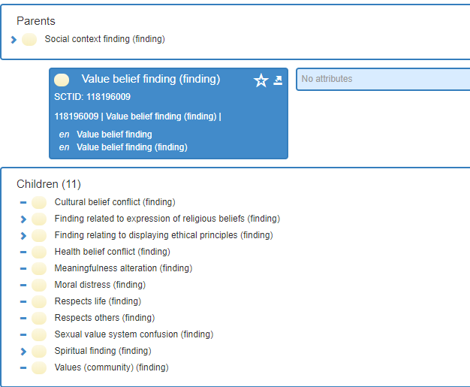

- Fully specified name, preferred term, and synonyms
NCPT term—not presently in concept, which is good as they do not appear semantically equivalent
- Substance or defining attribute
N/A

Current logical model:
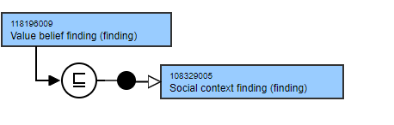

- Next steps
- Classification Subcommittee notes the following:
  - Beliefs and Attitudes are separate in SNOMED, thus 2 separate diagnosis concepts are required if needed.
  - The ‘or’ between ‘food or nutrition’ is a concern and would require one concept as well. Perhaps ‘nutrition’ could meet this need.
- An expert suggested two concepts (from the same expert who worked on the Beliefs/Attitudes nutrition assessment criteria revision for the 2020 Edition, Camella Rising, PhD, RD):
  - Nutrition belief finding inconsistent with scientific evidence (finding) with the current (Value belief finding) concept as the parent
  - Conflicting attitude about nutrition care (finding) with, 365484008 |Finding of attitude (finding)|, as a possible parent
- Any approach requires clarification of the concept/concepts by the NCPRO Committee.

Not ready for diet/lifestyle change (NB-1.3)

- Current concept mapping
SNOMED CT: 422981003 |Incongruent personal values (finding)|
- Relationships
Interprets → Mental state, behavior/psychosocial function observable (inferred, none stated)

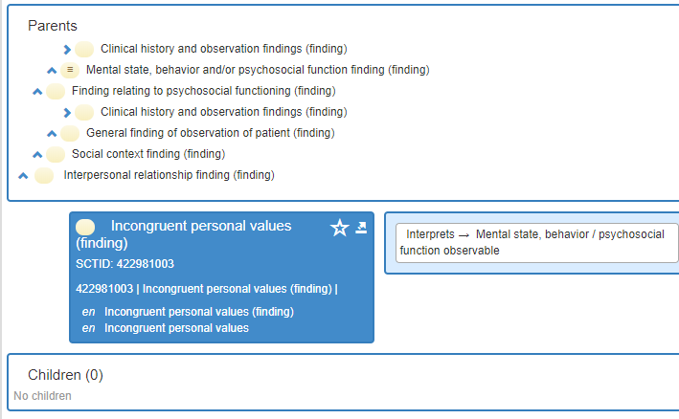

- Fully specified name, preferred term, and synonyms
NCPT term—not presently in concept, which is good as they do not appear semantically equivalent. NCPT concept is more specific.

- Substance
N/A

Current logical model:
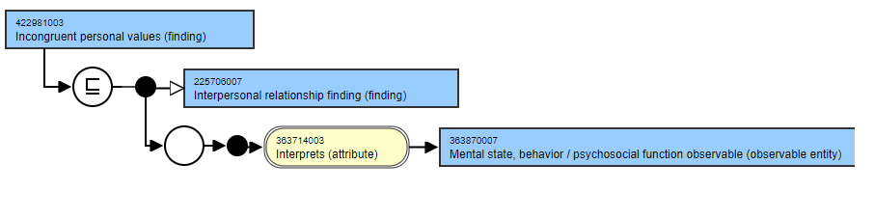
- Next steps
  - Classification Subcommittee notes the following:
- The concept must have the two ideas diet/lifestyle separated into different diagnoses (if needed), choose only one, or find an expression that encompasses both.
- Consider Not ready for nutrition behavior change or Absence of readiness for nutrition behavior change.
- Present mapping, Incongruent personal values, is not consistent with the NCPT concept and would require further examination by Classification for mapping and modeling based on the concept outcome.

Undesirable food choices (NB-1.7)

- Current concept mapping
SNOMED CT: 405241002 |Dietary indiscretion (finding)|
- Relationships
Interprets → Eating feeding/drinking observable

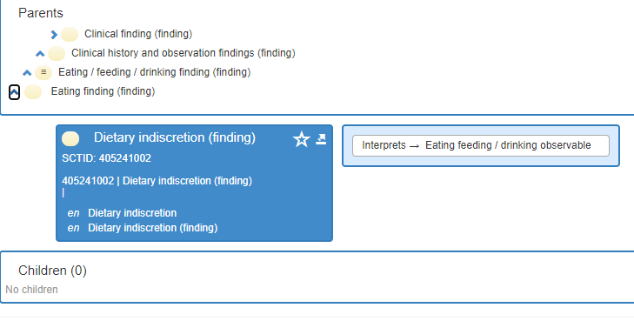
- Fully specified name, preferred term, and synonyms
NCPT term—not presently in concept.

- Substance
N/A

Current logical model:
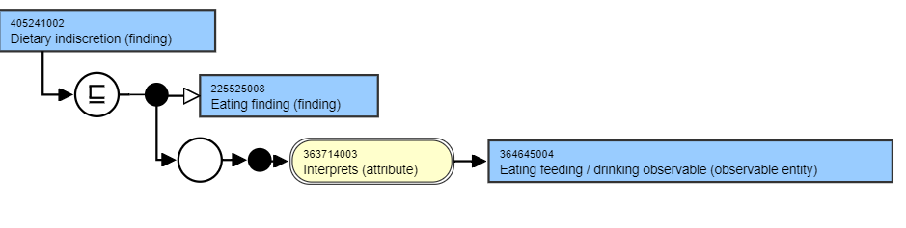

- Proposal

  - eNCPT synonym is Unbalanced diet. This was rejected as a synonym of Dietary indiscretion because it has its own concept in SNOMED: 424890008 |Unbalanced diet (finding)|
  - Recommend change mapping to this 424890008 |Unbalanced diet (finding)|

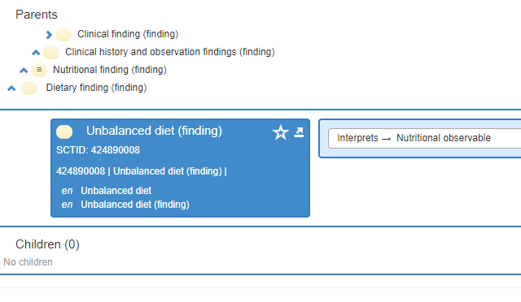

Impaired ability to prepare food/meals (NB-2.4)
- Current concept mapping
SNOMED CT: 286493007 |Difficulty preparing meal (finding)|
- Relationships
Interprets → Ability to prepare meal
Has interpretation → Able with difficulty
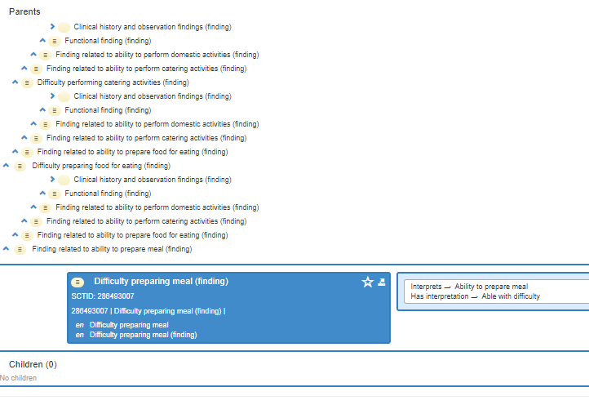

- Fully specified name, preferred term, and synonyms
NCPT term—not presently in concept. Limited ability to prepare food and meals is approved synonym. Both were submitted to SNOMED and both rejected as not semantically equivalent.

- Substance
N/A

Current logical model:
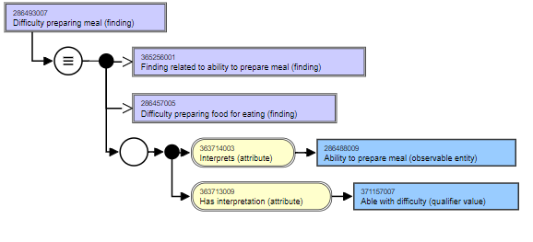

- Proposal

  - There are two issues: a) contains food/meals, and b) SNOMED stated that it considers neither the eNCPT term nor its synonym to be semantically equivalent with SNOMED concept.
  - Which concept—food or meal? 286457005 |Difficulty preparing food for eating (finding)| is the parent to this current concept, whose definition is: Cognitive or physical impairment that prevents preparation of foods/fluids.
  - Recommendation:
    - Rename concept to Difficulty preparing food for eating (especially since one does not have to ‘prepare a meal’ to eat and meal preparation is a narrower aspect of this concept)
    - Map to 286457005 |Difficulty preparing food for eating (finding)| as a better conceptual match
    - Revise NCPT synonym FROM Limited ability to prepare food/meals TO Limited ability to prepare food for eating 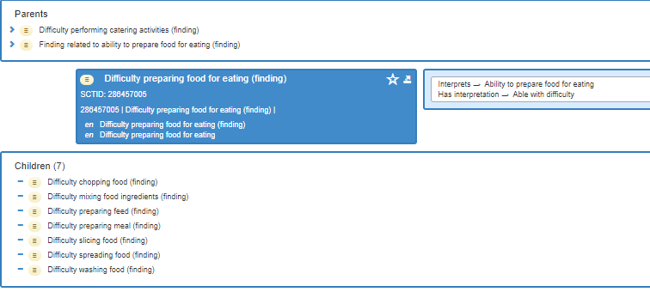
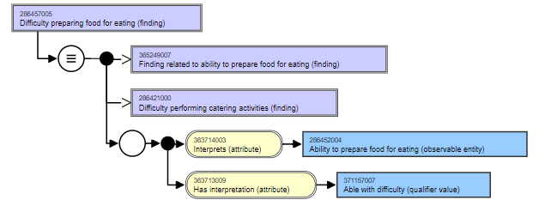

Self monitoring deficit (NB-1.4)

- Current concept mapping
SNOMED CT: 444781000124106 |Noncompliance with self-monitoring regimen (finding)|
- Relationships
Interprets → Compliance behavior

- Fully specified name, preferred term, and synonyms
NCPT term—not presently a concept synonym and this was deemed not a synonym when submitted to SNOMED; neither was its actual synonym Limited self monitoring.
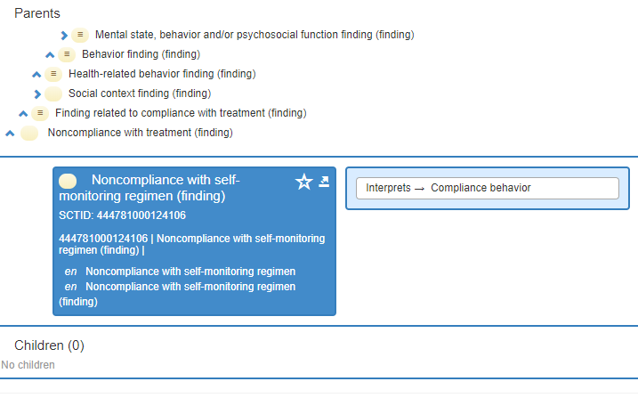
(inferred, not stated)

- Substance
N/A

Current logical model:
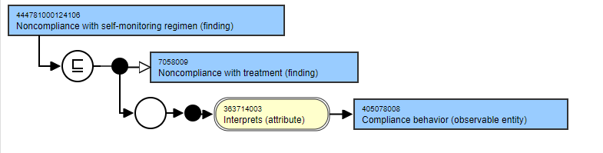
- Proposal
  - Recommend submission to SNOMED of: Able with difficulty to comply with self monitoring regimen with parent concept: 304900007 |Difficulty complying with treatment (finding)| for mapping this concept to instead of mapping to a noncompliance concept.
  - The wording is based on insight from the previous SNOMED editor for the NCPT who recommended the concepts under 442499005 |Interpretation value (qualifier value)| as those that are the approved (ie, Able, Able with difficulty, Unable).

Model Process Review
Approved During the September 2019 and updated on the February 2020 CPG Call
Assumptions and conditions:
- Each pilot test data concept will undergo the review.
- NCPT definitions are the source for clarification of a NCPT data concept. When needed, the source dictionary for NCPT, the Oxford English Dictionary (OED).
- NCPT clarifications can also be brought to Nutrition Care Process and Research Outcomes Committee Classification Workgroup.
- If clarification is needed in SNOMED, the consultants will ask for clarification from SNOMED CT editor who also has access to experts in each area of SNOMED terminology.
- CPG decisions regarding Observables hierarchy may have applicability for findings and interventions (procedures, regime/therapy) hierarchies.
- The Modeling Critical Thinking process is a work in progress that may need revision as the work continues.
Review includes:
- Current concept mapping
Examine complete hierarchical placement (all parents), listing concept ID and name, and assessment of agreement. Inaccurate modeling concerns will be described. Child terms for route, and where appropriate per kg body weight, concepts will be added or aligned with this modeling.

- Relationships
Identify and verify each relationship for accuracy to the concept.

- Substance or other defining concept (if applicable)
Review substance in substance hierarchy, for example.

- Fully specified name, preferred term, and synonyms
Review fully specified name, preferred term, and synonyms. If the concept is appropriate or when one is identified or included, ensure that NCPT is the preferred term or a synonym.

- Modeling review
Confirm if modeling is appropriate. If not, draft recommendations for proposed changes, seek review and approval of model with CPG, and review with SNOMED editor.

- Decision steps.
- CPG decisions regarding Observables hierarchy logic will be applied to ensure correct placement for findings and interventions (procedures, regime/therapy) hierarchies.
- Consultants will seek authoritative sources, for example, evidence guidelines or government resources (eg., Vitamin K) to resolve any questions.
  - Issues that cannot be resolved by consultants and SNOMED CT editor, will go to staff (C. Papoutsakis).
  - If not resolved, the next step will be to request expert input (identified experts in concept, eg, nutrition support issue sent to nutrition support experts).
  - Items still unresolved, will be brought to CPG for input.
- Draft model will be developed for review and approval by CPG of all pilot test concepts.
- References are needed for model changes.
- Models that appear accurate and/or require the addition of an NCPT synonym or nonsubstantive attribute (eg, increased, decreased) will be provided for consent.

