Terminology Pilot Modeling Review
March 2020 CPG Review

The model review process is at the end of the document.

Models for Review

NCPT: Nutrition related skill education (E-2.2)
- Current concept mapping
Current mapping is 445291000124103 |Nutrition-related skills education (procedure)|
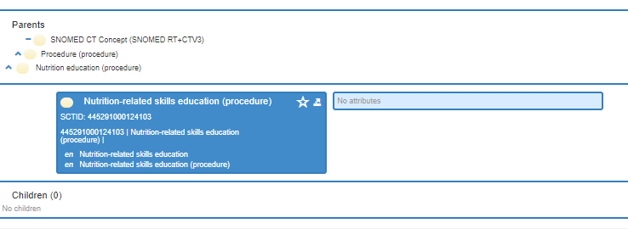
- Relationships
None

- Defining characteristics (substance/observable)
786839005 |Nutrition skill of individual client (observable entity)| (but in previous review for knowledge, the group suggested creating a concept Knowledge level of nutrition (rather than Nutrition knowledge of individual client) (Model follows for comparison).

- Fully specified name, preferred term, and synonyms
NCPT concept is singular and FSN is plural (somewhat unusual for SNOMED CT).

Current diagram:
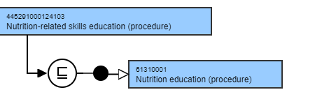
- Proposed Modeling
  - Define this procedure with a Has focus (attribute). Has focus uses the Clinical finding hierarchy for values, which could include the eNCPT Food and nutrition related knowledge deficit term.
  - Limiting that approach, right now, is that the nutrition diagnosis, Food and nutrition related knowledge deficit:
    - Food and nutrition related knowledge deficit, is modeled to SNOMED CT concept, 54777007 |Deficient knowledge (finding)|, which is not semantically equivalent.
    - It may be warranted for the NCPRO Committee to consider splitting this diagnosis into 2 concepts, one for knowledge and one for skills as is done in the NA/ME and NI terminologies.
    - To underpin a new concept like that would require creation of a general concept of Level of nutrition skills (observable entity) (or something like that as SNOMED CT does not have concepts like this). There is concept 786839005 |Nutrition skill of individual client (observable entity)|, but this is too specific (ie, ‘individual client’).

NCPT: Content related nutrition education(E-1.1)
- Current SNOMED CT concept mapping
Current mapping 445301000124102 |Content-related nutrition education (procedure)|

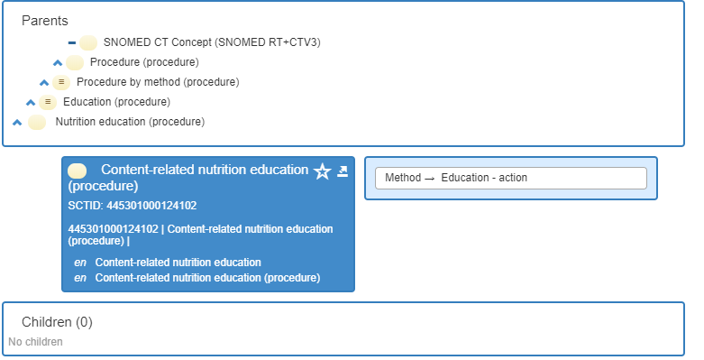

Parent 61310001 |Nutrition education (procedure)|

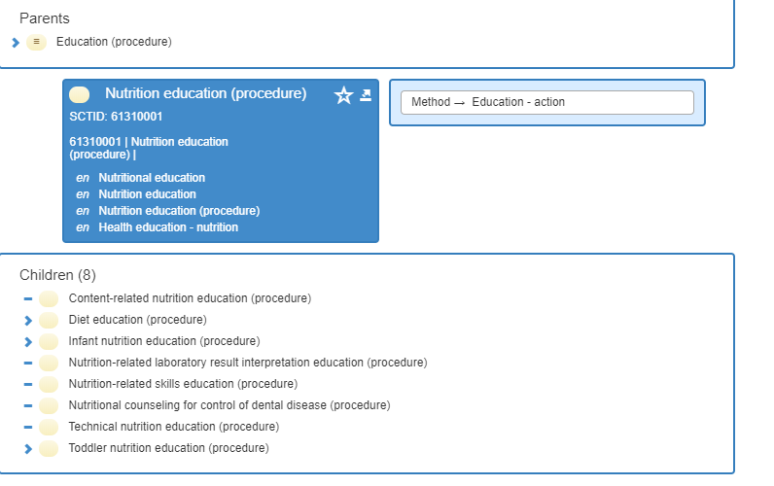
- Relationships
Method → Education – action

- Substance/observable
Education

- Fully specified name, preferred term, and synonyms
NCPT term is FSN.

- Proposal
  - The hierarchy placement is okay.
  - Define this procedure with a Has focus (attribute)-Clinical finding hierarchy for values, ie Food and nutrition related knowledge deficit
    - Food and nutrition related knowledge deficit, modeled to 54777007 |Deficient knowledge (finding)|
    - Submit a new concept to which we can map and model
    - Consider recommendation to NCPRO Committee to consider splitting this diagnosis into 2 concepts
    - Underpin knowledge portion by creating general concept of Knowledge level of nutrition (observable entity)

NCPT: Constipation (PD1.1.5.9)
- Current SNOMED CT concept mapping
Current mapping 14760008 |Constipation (finding)|

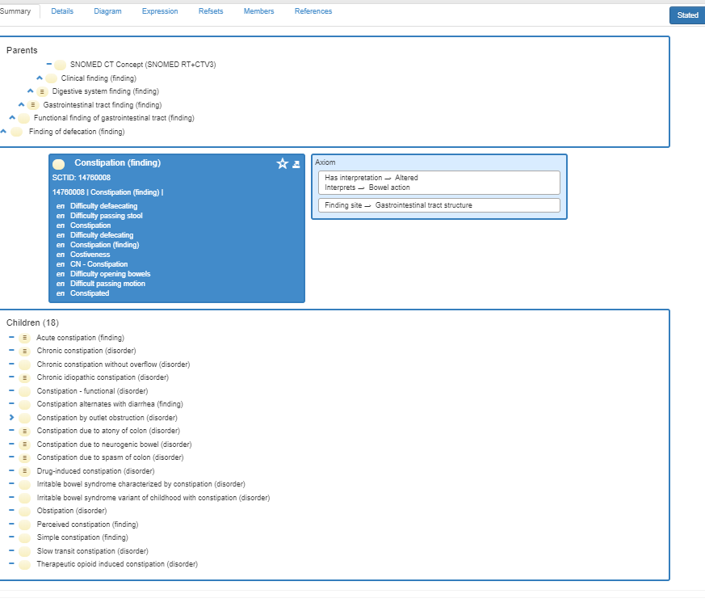

- Relationships
Has interpretation→ Altered
Interprets →Bowel action

Finding site →Gastrointestinal tract structure

- Substance/observable
Interprets →Bowel action

- Fully specified name, preferred term, and synonyms
FSN is NCPT term.

Current diagram:
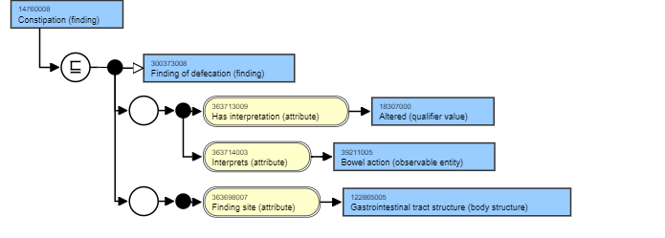
- Proposed Modeling
- Remove 122865005 |Gastrointestinal tract structure (body structure)| as the finding site and consider replacing it with 5668004 |Lower gastrointestinal tract structure (body structure)| because this is more accurate than the whole GI structure in the current model. (needs reference)
- This does create a potential conflict with another attribute of Interprets → 39211005 |Bowel action (observable entity)| since the new suggested concept (5668004) does not have the synonym ‘bowel.’
- 113276009 |Intestinal structure (body structure)| does have the synonym bowel, so this could be an alternate, but is not as accurate at Lower GI structure, which is where the constipation is occurring.

Model Process Review: Approved in September 2019 as Process for CPG Review
Assumptions and conditions:
- Each pilot test data concept will undergo the review.
- NCPT definitions are the source for clarification of a NCPT data concept. When needed, the source dictionary for NCPT, the Oxford English Dictionary (OED).
- NCPT clarifications can also be brought to Nutrition Care Process and Research Outcomes Committee Classification Workgroup.
- If clarification is needed in SNOMED, the consultants will ask for clarification from SNOMED CT editor who also has access to experts in each area of SNOMED terminology.
- CPG decisions regarding Observables hierarchy may have applicability for findings and interventions (procedures, regime/therapy) hierarchies.
- The Modeling Critical Thinking process is a work in progress that may need revision as the work continues.
Review includes:
- Current concept mapping
Examine complete hierarchical placement (all parents), listing concept ID and name, and assessment of agreement. Inaccurate modeling concerns will be described. Child terms for route, and where appropriate per kg body weight, concepts will be added or aligned with this modeling.

- Relationships
Identify and verify each relationship for accuracy to the concept.

- Substance (if applicable)/observable
Review substance/observable in hierarchy.

- Fully specified name, preferred term, and synonyms
Review fully specified name, preferred term, and synonyms. If the concept is appropriate or when one is identified or included, ensure that NCPT is the preferred term or a synonym.

- Modeling review
Confirm if modeling is appropriate. If not, draft recommendations for proposed changes, seek review and approval of model with CPG, and review with SNOMED editor.

- Decision steps.
- CPG decisions regarding Observables hierarchy logic will be applied to ensure correct placement for findings and interventions (procedures, regime/therapy) hierarchies.
- Consultants will seek authoritative sources, for example, evidence guidelines or government resources (eg., Vitamin K) to resolve any questions.
  - Issues that cannot be resolved by consultants and SNOMED CT editor, will go to staff (C. Papoutsakis).
  - If not resolved, the next step will be to request expert input (identified experts in concept, eg, nutrition support issue sent to nutrition support experts).
  - Items still unresolved, will be brought to CPG for input.
- Draft model will be developed for review and approval by CPG of all pilot test concepts.
- References are needed for model changes. (pending approval)
- Models that appear accurate and/or require the addition of an NCPT synonym or nonsubstantive attribute (eg, increased, decreased) will be provided for consent. (pending approval)

