**Nutrition Care Process Clinical Project Group**

**September 2019 Teleconference**

**Attachment 4.2: Pilot Test Process and Progress**

**Aim:** To ensure integrity of nutrition content in SNOMED CT

**What:** Modeling for approximately 100 concepts from Nutrition Assessment, Nutrition Diagnosis, and Nutrition Intervention. This includes new submissions and existing SNOMED CT content.

**Approach:**

1. Developed four common nutrition use cases: Gestational Diabetes Mellitus, Overweight/Obesity, Gastrointestinal Cancer, and Congestive Heart Failure.
   1. Chose case data elements from NCP terminology, based upon Evidence Analysis Library (EAL.org) guidelines for these conditions. Did not use all of the data elements identified in EAL as this would have exceeded desired number of concepts.
   2. Identified 103 NCPT concepts with SNOMED mappings.
      1. Examples with existing mappings: Ankle edema (PD-1.1.6.6) SCT ID 26237000, Excessive mineral intake (sodium) (NI-5.10.1.7) SCT ID 440921000124100.
      2. Examples of those added by Academy: Temporal wasting (PD-1.1.14.12) SCT-ID 719185000, Inadequate energy intake (NI-1.2) SCT ID 430176006, Inadequate protein intake (NI-5.6.1) SCT ID 430183004.
   3. Identified gap of twenty-five (25) nutrition assessment (observables) concepts and one (1) nutrition intervention concept (procedure) that are important to the project but did not have SNOMED mappings.
      1. Examples: Sodium estimated intake in 24 hours (FH-1.6.2.7), Total energy estimated intake in 24 hours (FH-1.1.1.1), Total protein estimated intake in 24 hours (FH-1.5.3.1.1)
2. Provided use cases and data elements to Nutrition Care Process Terminology Clinical Project Group (CPG) for review and approval, which was received.
3. Queried SNOMED to determine whether nutrition assessment observables (25 concepts) could be added to SNOMED for pilot.
   1. **Result**: SNOMED granted permission to add nutrition observable concepts.
4. CPG reviewed relevant SNOMED hierarchy for addition of nutrition assessment observables.
   1. **Result**: Decisions made by CPG determined hierarchy placement for nutrition observables for nutrient, energy, food, fluid, water, and breastmilk as well as some miscellaneous items.
   2. **Result:** Submission and acceptance of 31 concepts in July 31, 2019 release.
   3. **Result**: Draft observables template (A) developed and approved in concept by CPG. *Update*: Redraft template (B) necessary because additional concepts with route do not fully conforming to original template. Advised SNOMED editor that there are additional terms that are nutrient/substance intake per kg (of body weight) terms exist (eg, breastmilk intake estimated volume per kg in 24 hours), which may also impact template.
   4. **Result**: Requested deprecation of combined concept; 364386000 | Endocrine, nutritional and metabolic observable (observable entity), and placement of concepts under 64393001 | Nutritional observable (observable entity). Proposed for January 2020 Release]. See screen shot.
   5. Updates and Queries With New Submissions:
      1. Intake concepts that use original draft template are being updated to new template structure by SNOMED editor.
      2. ‘Energy’ is not a nutrient based on CPG decision and it is not a ‘substance’ in SNOMED. SNOMED observable group aware of this. Academy consultants are following observables group and attending meetings.
      3. As vitamin intake observables have been added, questions have raised regarding the appropriate substance to be used. *Example: Is ‘Vitamin K’ synonymous with Vitamin K1?* 
         * Consultants discussed with staff and confirmed using authoritative source (NIH Office of Dietary Supplements) that vitamin K in food, for example, is Vitamin K1 and K2.
         * Concurrently there is work on the substance hierarchy happening and a new option may be available—Vitamin K and Vitamin K derivatives that we believe is a match for the NCPT concept.
         * This same issue has come up with other vitamins and minerals.
         * We are not sure if all of the vitamins and minerals have this option but will monitor the situation*.*
      4. Breastmilk and soy milk are foods based on CPG decision, but under Dairy food in SNOMED.
      5. The appropriateness of using Concept 33463005 |Liquid substance (substance)| with ‘Fluid (substance)’ as a synonym was raised. Discussed with staff and it appears suitable.
      6. The word ‘Total’ in the intake concepts is inconsistently included in NCPT intake terms and SNOMED expressed a concern in July 2019 about this word generally in concepts. So,
         * 2020 Edition NCPRO Committee changes for Nutrition Assessment/Monitoring and Evaluation Terminology to only retain ‘total’ when intake is from all routes; remove the word ‘total’ when intake is from other routes, e.g., oral nutrition, enteral nutrition.
         * Will propose to SNOMED to Include Total term (all routes) ie, Total protein estimated intake in 24 hours (FH-1.5.3.1.1) as a synonym for SNOMED concept, Estimated protein intake in 24 hours.
   6. Review and verify changes in each SNOMED release.

Deprecation of Endocrine, nutritional and metabolic observable (observable entity)

**Current**

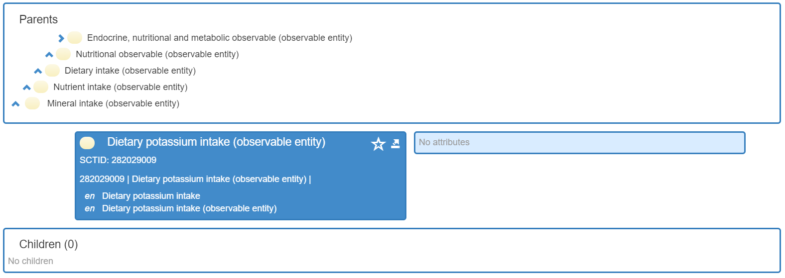

**Proposed**

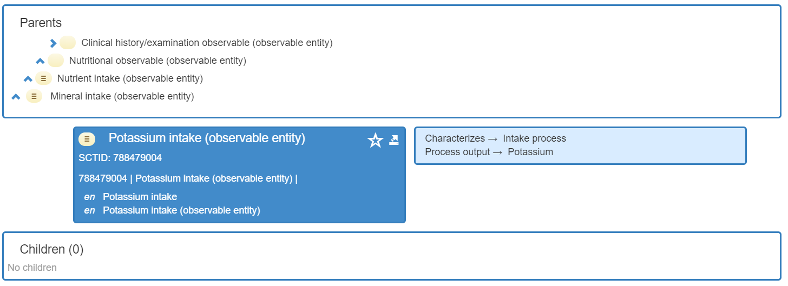

Template A

Template B

